EXDON 30.09.2024
- Draw softboxes, relationship lines, and labels for each relationship in both directions.

- Each EMPLOYEE must hold one and only one JOB. Each JOB may be held by one or more EMPLOYEEs.

- Each PRODUCT must be classified by one and only one PRODUCT TYPE. Each PRODUCT TYPE may classify one or more PRODUCTs

- Each TOWN may be the birthplace of many PEOPLE. Each PERSON must be born in one and only one town.

- Each ROOM may house one or more GUESTs. Each guest may stay in one and only one room.

- Each EMPLOYEE must work for one and only one DEPARTMENT. Each DEPARTMENT may have one or more EMPLOYEEs.

- Each MESSAGE must be addressed to one or more PEOPLE. Each PERSON may be the addressee of one or more MESSAGEs.

- Each STUDENT may learn from one or more TEACHERs. Each TEACHER may educate one or more STUDENTs.


- Read the given business scenario. Name the relationships between EMPLOYEE and JOB. Include appropriate optionality and cardinality.

“We have a lot of employees who handle one or more different jobs. We’d like to keep track of who is working on which job. Although employees can help each other, a job is assigned to one employee and is the ultimate responsibility of that employee. All of our employees have at least one job. However, jobs exist that are not yet assigned to anyone.”
Employee may have one or more job. Each job may have one and only one employee.


- Read the given business scenario. Name the relationships between PARENT and CHILD. Include the appropriate optionality and cardinality.

“At the end of each day, parents need to pick up their children at our day-care center. All children must be picked up by 6 p.m. A child may have two parents, but we need only one of them to come and pick up the child. We cannot release a child to anyone but that child’s parent.”
Each child must be picked up by one and only one parent. Each parent must picked up their child.


- Read the given business scenario. Name the relationships between TEACHER and STUDENT. Include the appropriate optionality and cardinality.

“Some students request remedial help in certain subjects, such as math. We can assign a tutor who can work with the student after class. Some of our teachers agree to be tutors. If several students need tutoring in one subject, then we assign them to the same teacher. If a student needs tutoring in several subjects, then he will probably be assigned to several different tutors.”

Each student may request remedial help form one or more teacher. Each teacher may agree to tutor a student


- Check if the following statements are true or false.

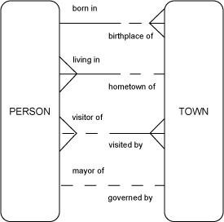
- Each town may be the birthplace of one and only one person.
- Each person must be born in one and only one town.
- Each person can live in one and only one town.
- Each town may be the birthplace of many people.
- Each person must be born in one or more towns.
- Each person must live in one and only one town.
- Each town must be the hometown of many people.
- Each person may be visitor of more towns.
- Each town must visit by one and only one person.
- Each town may be governed by more people.
- Each person must be mayor of one and only one town.
- Each town may be the hometown of one and only one person.
- Each person may be visitor of one or more towns.
- Each town must visit by many people.
- Each town may be governed by one and only one person.
- Each person may be mayor of one and only one town.

- Draw ERDs for each of the following scenarios. Draw softboxes, relationship lines, and labels for each relationship in both directions.

- “I am an agent for several musicians and bands. A musician may be a solo performer or may belong to a band. A band will always have one or more musicians in it. Some musicians are a one-man band. However, a musician can belong to only one band. Since I schedule them for concerts and events, I need to keep track of certain information: the musician’s first name, last name, address, phone number, and hourly rate. If it’s a band, I need to know the band name in addition to the information I already keep for the member musicians. I’ve handled bands with the same name, so just to make sure I book the right band, I assign an ID to each one. The hourly rate for a band is the total of the hourly rates of its members.”
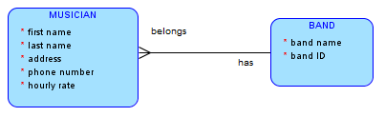

- “Some students request remedial help in certain subjects, such as math. We can assign a tutor who can work with the student after class. Some of our teachers agree to be tutors. If several students need tutoring in one subject, then we assign them to the same teacher. If a student needs tutoring in several subjects, then he will probably be assigned to several different tutors.”



